**Project Milestone 2**

**Team Members and Roles:**

|  |  |
| --- | --- |
| Area/Topic | Responsible Team Members |
| Project Manager and Team Lead | Tarun Sarpanjeri |
| Content Developer | Tarun Sarpanjeri, Alekhya Jaddu |
| Web Application Developer | Sai Rohith Gorla, Navya Devineni |
| User Interface Developer | Navya Devineni, Sai Rohith Gorla, Alekhya Jaddu |

**Project Integration Management**

1. **Updated Project Charter:**

Project Charter

Date: 05/23/2020

Project Charter

Date: 05/17/2020

|  |  |  |  |
| --- | --- | --- | --- |
| **Project Title**: Getaway Groceries-Online Grocery Store | | | |
| **Project Start Date:** 05/17/2020 **Projected Finish Date:** June 2020 | | | |
| **Budget Information:** Provided by Client based on resources. We are estimating $250,000 dollars from client. | | | |
| **Project Manager:** Tarun Sarpanjeri, +1(660)528-0515, S537916@nwmissouri.edu | | | |
| **Project Objectives:**  To develop web application for creating a user friendly eCommerce website where customers are able to purchase and check out their products easily without any trouble and getting stuck in any process starting from placing the order till the order getting placed confirmation. | | | |
| **Success Criteria:**  Meeting triple constraints (Cost, Scope, Schedule) and customer satisfaction.  Fulfill Client Requirement | | | |
| **Approach:**  Agile Methodology | | | |
| **Roles and Responsibilities:** | | | |
| ***Name and Signature*** | ***Role*** | ***Position*** | ***Contact Information*** |
| Tarun Sarpanjeri  C:\Users\S537916\Downloads\WhatsApp Image 2020-05-18 at 19.38.22.jpeg | Project Manager/Team Lead/Content Developer | Manager | **S537916@nwmissouri.edu** |
| Alekhya Jaddu | Web application  Developer/User Interface Developer | Sr. Developer | **S538343@nwmissouri.edu** |
| Navya Devineni | Web application  Developer/User Interface Developer | Jr. Developer | **S538339@nwmissouri.edu** |
| Sai Rohith Gorla | User Interface Developer/ Content Developer | Senior | **S538416@nwmissouri.edu** |
| **Comments:** (Handwritten or typed comments from above stakeholders, if applicable) | | | |

1. **Project Management Plan**

Project Management Plan Version 1.0

Date: 05/23/2020

**Project Name:** Getaway Groceries-Online Grocery Store

**Introduction/Overview of Project:**

To develop web application for creating a user friendly eCommerce website where customers are able to purchase and check out their products easily without any trouble and getting stuck in any process starting from placing the order till the order getting placed confirmation.

Evolution of this website:

There are several stages and modifications in the project from start to finish. The changes are well documented in Microsoft Office and Google Documents, so they can be viewed and worked simultaneously by all of the team members. All the proposals for improvements are officially submitted by a team member to build a user profile and the project manager 's commission is set up to agree on the changes. The main purpose of Google Docs is to save these changes as formally noted as the requests for changes continue to appear.

**Project Organization:**

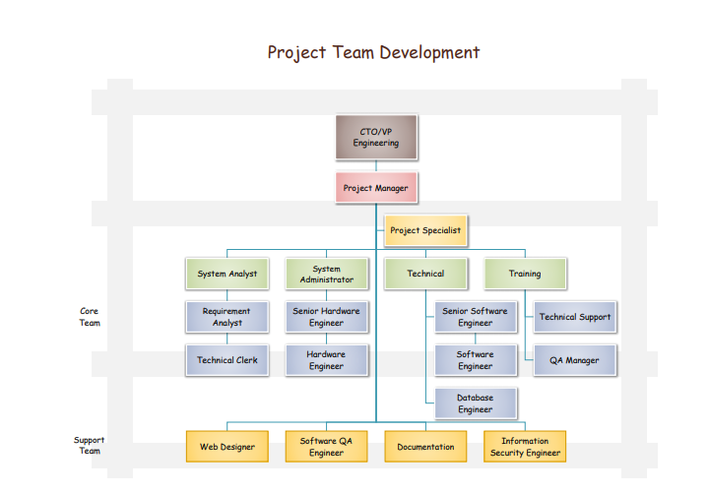

**Management and Technical Processes**

**Management Processes**:

**Management Objectives and Priorities:**

The top most priority of the Management is ensuring that the product is delivered within the time and budget and is functioning properly without any glitches.

Once a new proposal comes up, the management committee decides whether a change needs to be accepted or not.

**Assumptions, Dependencies, and Constraints:**

The project should always satisfy the triple constraints scope, quality and time.

**Risk Management:**

When some risk occurs in our project first, the root cause is identified and the root cause is minimized by the risk management techniques which are needed and is typically managed by the risk management department.

**Monitoring and Controlling Mechanisms:**

Monitoring and Controlling systems are very important and play a very important role in a project, as these mechanisms will allow us to verify the outcomes of the projects are properly evaluated. When there are any issues or significant changes, these mechanisms will identify and monitor the issues throughout the project.

**Staffing Plan:**

The Project mainly requires a project manager, program manager, database analyst, programmers, test engineers, and other staff which are to be highly skilled with good professional behavior and proper soft skills.

**Technical Processes:**

**Methods, Tools, and Techniques:**

Microsoft Excel, HTML, Bootstrap MD, React, JavaScript, Node Js, Microsoft Office, JIRA.

**Software Documentation:**

Documentation is the main part of Software Engineering Process. Software designed by the each individual must be neatly presented so the every individual can understand how the software functions and what requirements should be followed when designing a program.

**Project Support Functions:**

While we adopt the Agile Methodology, the scrum master will also organize scrum meetings to monitor the progress of every task assigned to each project member and whether there are any changes in the current process.

Project Manager will be monitoring the application performance and addresses the changes in the project Life cycle.

**Work to Be Performed**

A work package is the lowest component of the WBS, sometimes referred to as the terminal element of a WBS structure. If you decompose a deliverable into component while creating a work breakdown structure, you create a working package. All factors, such as a budget, material(s), personnel, timetable, milestone and the best technology to use, will be included.

**Schedule Information**

The project has been started on 05/17/2020 and will end on 06/12/2020. The project time management plan has a detailed schedule of the project.

**Budget Information**

The estimated budget of the project is $250,000. Based on the Project Team, Resources required for developing a project, technologies used the project Manager will allocate all those resources accordingly.

**References to Other Project Planning Documents:**

A Guide to the Project Management Body of Knowledge (PMBOK Guide) 2000 edition - Project Management Institute.

We have referred to many documents and done a thorough study on how it can be useful to our project Online Grocery store Website. After going through all the articles we have chosen the above as reference and thought it would serve better for our project Management.

**Project Scope Management**

1. **Scope Statement**

Scope Statement (Version 01)

|  |
| --- |
| **Project Title: Getaway Groceries- Online Grocery Store**  **Date:05/23/2020** **Prepared by:** Tarun Sarpanjeri |
| **Project Justification:**  The main Objective of our project is to create a user friendly eCommerce website where customers can easily purchase and check out their products in a smooth way without getting stuck anywhere in the process starting from placing the order till the order getting placed confirmation. |
| **Product Characteristics and Requirements:**   1. The Application should have a login page which takes username and Password. On Successful login users should be navigated to the our website 2. The Application have a navigation bar with different pages like you can select the different items like snacks, pharmacy and deals for the day. 3. After selecting items our website generates total bill information like their tax and discounts on selective products and final receipt. 4. After selecting your items you will redirected to payment page where you can select your payment based on interest and enter the billing address of your payment. 5. Finally after successful payment your items are ready for delivery. |
| **Product User Acceptance Criteria:**  The product is supposed to meet all the functionalities with User Interface and satisfy end user, customer and the stakeholders. Delivery the product on time without delays.  **Summary of Project Deliverables**  **Project management-related deliverables:** business case, charter, team contract, scope statement, WBS, schedule, cost baseline, status reports, final project presentation, final project report, lessons-learned report, and any other documents required to manage the project.  **Product-related deliverables:** research reports, design documents, software code, hardware, etc.   1. Better customer service. 2. Faster response time. 3. A tested and operational website without errors and meeting the specifications described in the project description. 4. A presentation meeting with the client to ensure project satisfaction. |

PROJECT COST MANAGEMENT

**COST ESTIMATE:**

